University Patents and Patent Policy Debates: 1925-1980

David C. Mowery
Haas School of Business
U.C. Berkeley

Bhaven Sampat
Economics Department
Columbia University

Prepared for the Conference in Honor of Richard Nelson, Columbia University, October 13-15, 2000. The research for this paper was supported by the Alfred P. Sloan Foundation, the Andrew W. Mellon Foundation, Columbia's Office of the Executive Vice Provost, the U.C. President’s Industry-University Cooperative Program, and the California Policy Seminar. We are grateful to Dick Nelson, Michael Barnes, and Arvids Ziedonis for numerous discussions, comments, and research assistance.

1. Introduction
Government technology policy has been an important topic in Richard Nelson’s research agenda throughout his career. Nelson and colleagues have made a number of contributions to the comparative analysis of this topic, assessing the roles of policy in different industries and countries (1982, 1984), comparing the “national innovation systems” of industrial and industrializing economies (1993), and examining the sources of industrial leadership in a set of industries in the United States, Western Europe, and Japan during the past century (Mowery and Nelson 1999). Nelson’s work on innovation systems highlights the role of institutions within the technological development of national economies—in most complex industrial economies, national technology policies are mediated by intermediate institutions, be these firms, governmental entities, or other structures. Understanding the operation and evolution of national innovation systems therefore requires an analysis of the ways in which policies within these institutions develop, as well as an analysis of the interaction between national or sectoral policies and these institutions.
In recent work, Nelson and colleagues also have devoted considerable attention (notably, in Rosenberg and Nelson, 1994) to the changing role of the U.S. university system within this nation’s innovation system. In their paper, Rosenberg and Nelson argued that U.S. universities maintained close links with industry in their research and educational activities through much of the 20th century. Among other things, this interpretation of the role of U.S. universities calls into question the argument that university-industry technology transfer has become economically significant during only the last two decades. The emergence of these university-industry linkages reflected a number of unusual structural characteristics of the U.S. national university structure (notably, its decentralized, pluralistic structure and the prominent role of state governments in supporting many public universities), as well as changes in public R&D investment and intellectual property rights policies.
Although university-industry research linkages have a long history in the United States, the structure of these relationships has changed considerably during the past 75 years. Patenting of US university inventions dates back to the earliest years of the 20th century, but for much of the 1900-75 period, US universities resisted direct involvement in this activity and some discouraged patenting. During the 1970s, however, this position began to change, and many universities (particularly private institutions) for the first time became directly involved in the management of their patent portfolios. The Bayh-Dole Act accelerated these trends, but they were well-established by 1980, the year of the Act’s passage.
This paper examines the evolution of U.S. university patent policies and the available data on university patenting during the “pre-Bayh-Dole” era. Analysis of the debates over university patenting reveals that while many of the issues in recent debates about the costs and benefits of university patenting were articulated as early as the 1930s, several arguments in favor of university patenting that were prominent in these early debates did not appear in the debates over Bayh-Dole. And a widely held premise of the earlier debates, that universities should avoid a direct role in managing patents and licenses, scarcely appears in the debates of the 1970s. Our examination of U.S. university patents during the 1925-1980 period focuses on change in the overall level of patenting and in the characteristics of the universities active in patenting. One of the most striking shifts in these data is the rapid growth of patenting by private universities, many of which had avoided patenting, during the 1970s, as well as the broader expansion of direct university involvement in patent management during this period.

2. A Brief History of U.S. University Patent Policies

2.1 The Pre-World War II Debate
Just as the post-1975 surge in US university patenting coincided with a broader rise in university-industry links (Mowery et al. 1999, Henderson et al. 1998), so did the first wave of university involvement in patenting, which began after World War I. Expanding links between university and industrial research during the 1920s and 1930s triggered a debate among U.S. research university administrators over patent policy (McCusick 1948; Palmer 1934).
In 1933, the American Association for the Advancement of Science (AAAS) Committee of Patents, Copyrights, and Trademarks surveyed the different positions on "patent problem," as it was then known, that faced university scientists. Among the questions addressed by the report were: "Should [scientists] proceed to obtain patents? What are the advantages in doing this? What are the disadvantages?" (7). The final report of the AAAS committee supported university patenting, although it was much less enthusiastic about active university involvement in patent management. The report’s summary of this debate in the 1930s about university patenting in some respects resembles, and in others contrasts with, the debates that occurred four decades later over Bayh-Dole.
The committee first considered whether patenting was necessary for "technology transfer." Although a common criticism of academic patenting was "that publication or dedication to the public is sufficient to give the public the results of work of scientists" (9), the report concluded that this position was naïve, for several reasons. First, anticipating a central argument made in the 1970s in support of the passage of the Bayh-Dole Act, the Committee noted:
"Discoveries or inventions which are merely published and thus thrown open equally to all, unless of great importance to the industry, are seldom adopted … Ordinarily no manufacturer or capitalist would be willing to-day to risk his money, and expend time and energy in developing on a commercial scale a new product or process without being assured that his investment in developing the invention would be protected in some measure. . . " (10).

The Committee argued that a scientist could not expect that publication alone would lead his inventions to yield social benefits because of the presence of "patent pirates" who would "wrongfully appropriate his work" and "deny the public what he thought he gave it," either by charging monopoly prices or withholding the invention from use (10). University patenting would reduce these risks.
A related argument--particularly prominent in the discussion of biomedical research--was that patents on university inventions were necessary for "quality control" reasons. Patenting of university research advances would prevent the unsuccessful or even harmful exploitation of university research advances by unqualified individuals or firms. Incompetent exploitation of academic research, which might discredit the research results and possibly the university, thus could be avoided by patenting such advances.
Proponents of university patenting largely assumed that doing so enhanced the public good. University patents advanced social welfare by inducing parties to develop and commercialize university research results, by preventing "patent pirates" from themselves patenting the research and charging monopoly prices, and by allowing institutions to ensure that only reputable parties developed the research, protecting the reputations of the invention and the university itself. Realization of the first of these aims (commercialization), however, might require that any patented research results be licensed on an exclusive or semi-exclusive basis. Prevention of “patent piracy” and protection of universities’ reputations required only that an institution obtain a patent and license it widely at low or no royalties. As we note below, the first of these three arguments ("patents induce development") figured prominently in debates about university patent policy in the 1960s and 1970s (Mazzoleni and Nelson 1998; Eisenberg 1996) although the second and third of these arguments were absent.
The Committee’s report also addressed the potentially negative effect of patents on the progress of research, especially in fields where advances are cumulative. Once again, the report cites Sevringhaus (1932), generally a supporter of university patenting, who warned:
"An example of the danger of grave disadvantages is contained in the possibility that a patent for a 'discovery' in such a shifting field as that of internal secretions may be granted when no real advance has been made, but that this patent will serve to place very unfortunate strictures on other men who subsequently do fundamental work in the same field" (234).

This concern is echoed in contemporary debates over the advisability of patenting research tools (National Research Council, 1997) and in criticisms of the desirability of patents in areas of research in which progress is “cumulative,” i.e., research advances require access to the results of previous work (Merges and Nelson 1994). The Committee acknowledged these dangers, but argued that universities could avoid them "by permitting the use of patents on liberal terms … [which] is particularly necessary in the case of broad or basic inventions" (12).
A third class of issues in the Committee report dealt with the tension between university patenting and the “open science” norms and institutions of academe (Merton 1973). Objections to patenting based on this view included assertions "that it is unethical for scientists or professors to patent the results of their work" (the Committee Report indicated that "[t]his objection is probably the vaguest and most frequent one raised"), but also anticipated contemporary fears that allowing university scientists to take out patents would hinder communalism and would distort academic inquiry away from basic research (Dasgupta and David 1994; Mowery et al 1999). The Committee’s report acknowledged and dismissed these concerns.
The debates over university patent policies in the 1930s treated medical patents as a special case. Opposition to medical patents was widespread, based on the argument that patents restricted the use of new discoveries and therefore had no place in the medical community (Weiner 1986). Opponents of medical patents also expressed concern over public perceptions of university profiteering at public expense in the field of public health (McCusick 1948). The AAAS Committee acknowledged the "special" nature of patents in the field of public health (with little elaboration), but suggested that the benefits of patenting discussed above, particularly the "quality control" mechanism, were sufficient to warrant university patenting of such discoveries.
This reluctance to patent biomedical discoveries is especially paradoxical in view of the fact that biomedical inventions proved to be the leading sources of patent licensing revenues for U.S. universities throughout the 20th century (see below). Indeed, the AAAS Committee Report omitted any mention whatsoever of the potential licensing revenues associated with any class of university patents, although the prospect of such revenues motivated a number of institutions to expand their patenting activities during the 1930s.
Although the AAAS report favored university patenting of faculty inventions, the committee was not enthusiastic about direct involvement by universities in patent management, arguing that the many problems that patent management might present to universities could be avoided "by assigning important patents to competent and experienced existing organizations for their commercialization" (9). This recommendation is not entirely surprising; one of the members of the AAAS Committee was Frederick Cottrell, founder of the Research Corporation, a nonprofit entity established to manage university patents that devoted a portion of its revenues to supporting scientific research (see Mowery and Sampat, 2000, for a more detailed discussion).
This review of the early debates about university patenting suggests that a number of US university scientists were indeed interested in patenting well before the 1970s and 1980s. The primary motivation for patenting was the protection of the public interest and the preservation of academic institutions’ reputations, although medical patents were a special case that required specialized policies. As we see below, however, potential profits did influence the decision of several universities to enter into patenting and licensing. Nonetheless, through much of the 1925-80 period, many academic scientists and administrators preferred to avoid direct involvement in the management of these patents. All of these tensions and debates were reflected in the patent policies adopted at the leading pre-1940 institutional patenters and licensors.

2.2 Pre-World War II University Patent Policies: An Overview
Since one of the forces that led universities towards development of patent policies and procedures was the rise of links with industry, it is not surprising the first group of universities to become involved with patents were land-grant universities, many of which conducted applied research of interest to industry (Rosenberg and Nelson, 1994). Many of these institutions sought patents for faculty inventions in the expectation that state taxpayers and the local economy would benefit from their research. But even these "applied" schools frequently avoided a management role in patenting and licensing (Committee on Uniform Patent Practices, 1922).
The intense financial pressures on many universities resulting from the Great Depression of the 1930s, as well as the ability of institutions such as the University of Wisconsin to reap significant revenues from patent licensing, sparked greater interest on the part of universities in patenting in the 1930s. Wisconsin first became concerned with patents following the development of a potentially valuable invention by a faculty member. In 1924, Dr. Harry Steenbock of the University of Wisconsin developed a method for using irradiation to increase the vitamin D content of food and drugs. In the face of criticism by many in the medical community and his colleagues at the University, Steenbock patented his findings, arguing that patenting was necessary to protect the public from unscrupulous firms and from potential monopolization of the invention by a private patentholder (Apple 1996). The University was not interested in managing these patents, and Steenbock convinced several alumni to create the Wisconsin Alumni Research Foundation (WARF), an affiliated but legally separate foundation that would accept assignment of patents from University faculty, license these patents, and return part of the proceeds to the inventor and the University.
During the 1930s, several other state universities (including Purdue and the University of Cincinnati) followed Wisconsin in setting up similarly affiliated but legally separate foundations to manage patenting and licensing. But the political protection afforded to the University of Wisconsin by its foundation proved to be limited. The University of Wisconsin was criticized when WARF allegedly restricted oleomargerine producers from using Steenbock's process in order to protect the Wisconsin dairy industry (McKusick 1948; Apple 1996). The criticism of the university led other universities such as MIT to consider other options for patent management (Fishman 1996).
Prior to 1930, MIT did not have an institutional patent policy. Newly inaugurated MIT President Karl Compton appointed a committee (headed by MIT Vice-President Vannevar Bush) to make recommendations on ways, including patenting, in which the Institute could use faculty research discoveries to strengthen MIT’s Depression-battered financial condition (Fishman, 1996; McKusick 1948). In 1932, the Institute announced a policy that asserted its rights to all faculty inventions. Rather than assuming a direct role in managing these patents or establishing an affiliated foundation, however, MIT signed a contract in 1937 with the Research Corporation to administer its patent portfolio. Under the terms of this "Invention Administration Agreement," MIT disclosed potentially patentable inventions to the Research Corporation. The Corporation agreed "to use its best efforts to secure patents on inventions so assigned to it and to bring these inventions into use and derive a reasonable income therefrom" and further to "use its best efforts to protect these said inventions from misuse and to take such steps against infringers as [it] may deem for the best interest of the parties hereto, but with the general policy of avoiding litigation wherever practicable." All license revenues were shared by the Institute and Research Corporation on a 60/40 basis.
This third-party technology transfer model allowed MIT to reap the benefits of licensing while avoiding direct involvement in the potentially controversial business of patent management. Columbia and Princeton signed similar Invention Administration Agreements with the Research Corporation in the late 1930s.
Table I summarizes the 1940 patent policies of the 16 U.S. universities classified by Geiger (1986) as leading research universities before World War II: Illinois, Michigan, Minnesota, Wisconsin, California, Columbia, Harvard, Pennsylvania, MIT, Cornell, Johns Hopkins, Princeton, Yale, Stanford, Chicago, and the California Institute of Technology. As of 1934, only two of these institutions had adopted formal patent policies. By the end of the 1930s, however, twelve had done so, reflecting the growth of institutional concern over patent management.
Several elements of these policies deserve mention. First, despite evidence of increased institutional interest in patenting among the leading US research universities and a few other institutions, most US universities lacked any patent policies before World War II (Palmer 1957). Several universities with patent policies, including Harvard, Penn, Chicago, and Johns Hopkins, had adopted policies that discouraged patenting or prohibited the university or faculty from patenting, especially in the field of medicine. Nonetheless, with the exception of the University of Chicago, each of these “anti-patent” institutions acknowledged that under special circumstances patents might be necessary, even in medicine, for "quality control" purposes of the sort discussed earlier. A number of institutions used research foundations or the Research Corporation for patent management (Table I), reflecting their aversion to in-house patent management. The onset and aftermath of World War II would change much of this landscape, as we discuss in the next section.
TABLE I HERE

2.3 The Impact of World War II
US involvement in World War II and the Cold War transformed the structure of the US national innovation system (Mowery and Rosenberg, 1998). Nowhere was this transformation more dramatic than in US universities. Formerly funded largely by state governments, the U.S. Agriculture Department, and industry, academic research experienced a surge of federal funding. The prewar weakness in academic science that typified the vast majority of US universities (a weakness that had begun to dissipate during the 1930s) by comparison with their European counterparts gradually was replaced by excellence in a broad array of fields. The expansion in federal support for academic research during and after World War II intensified university involvement in patent issues.
As the growth in university-industry links had done during the 1920s and 1930s, increased federal funding of university research strengthened two motives for university involvement in patenting. First, the expanded scale of the academic research enterprise increased the probability of a patentable invention. Second, many federal research sponsors required the development of a formal patent policy. Summarizing the survey of US universities that he conducted during the late 1950s, Palmer (1962) found that 85 universities had adopted or revised explicit patent policies during the 1940-55 period; more than half of these new or revised policies were announced during 1946-55. McKusick (1948) suggests that by the late 1940s, virtually all major US universities had developed patent policies, an estimate that contrasts sharply with the pre-1940 situation.
McKusick (1948) found considerable diversity in universities’ patent policies after World War II (see also Palmer 1952, 1962). Typically, patents from government funded work were governed by the policies of the sponsoring agency (see below); privately sponsored research was dealt with on a case-by-case basis, although sponsors typically received some preferential treatment. Significant differences remained among universities in their assertion of rights to faculty inventions and their willingness to pursue patent licenses.
Moreover, although some universities, including the University of California, the University of Florida, and Stanford, were managing their patents internally by the 1950s, most institutions left patent management to legally separate entities such as research foundations or the Research Corporation (McKusick 1948). This reflected both the need for "insulation", as discussed above, and the fact that most universities lacked such expertise. The dimensions of this postwar "outsourcing" trend are apparent in Table II, which shows the growth during the postwar period in the number of institutions with invention administration agreements with the Research Corporation.
TABLE II HERE
Well into the 1960s, U.S. university patent policies and procedures reflected the ambivalence toward patents that was revealed in the debates of the 1930s. Many institutions continued to avoid direct involvement in patent administration, and others maintained a "hands off" attitude towards patents altogether. Columbia's policy left patenting to the inventor and patent administration to the Research Corporation, stating that "it is not deemed within the sphere of the University's scholarly objectives" to hold patents. Harvard, Chicago, Yale, and Johns Hopkins took similar positions, and together with Ohio State and Pennsylvania discouraged or prohibited medical patents. Other universities allowed patents only if it was clear that patenting would be in the public interest. But this institutional ambivalence toward patenting began to change during the 1960s, although the prohibitions on medical patenting at Columbia, Harvard, Johns Hopkins, and Chicago were not dropped until the 1970s. The pace of change accelerated during the 1970s, in response to initiatives in federal R&D funding and patent policy.

2.4 The Growth of University Involvement in Patent Management, 1960-80

2.4.1 Growth in Federal Research Support
Although federal support for academic research grew during the first postwar decade, the rate of growth in such support accelerated in the late 1950s, and the composition of this support shifted in favor of basic research. Between 1958 and 1968, federal funds for basic research in U.S. universities increased seven-fold. U.S. universities performed 25% of national basic research in 1953, 36% in 1960, and 50% by 1968 (all figures from Geiger, 1993). The greatest increases in funding in the late 1950s and 1960s were in the biomedical sciences, funded largely by the Department of Health and Human Services, which housed the National Institutes of Health (Geiger 1993). The HEW share of total academic R&D funds grew from 40% in 1963 to 50% in 1979 during a period when overall federal support for university research grew nearly five-fold (NSF 1996). These increases in federal research funding, especially in biomedical research, elevated the salience of patent management issues at many universities.
The postwar era also saw increased dispersion in the inter-institutional distribution of federal support for university research. During and immediately after World War II, federal funds were overwhelmingly concentrated in a handful of institutions. The redistributive instincts of Congress contributed to the development during the 1960s and 1970s by most major federal funding agencies of programs to distribute funds more broadly (Graham and Diamond 1997). The share of federal R&D funds accounted for by the ten leading academic recipients of these funds shrank from 43% in 1952 to 37% in 1958, and declined further still during the 1960s and 1970s (Table III). In the life sciences, where funding was less institutionally concentrated than overall federal academic research funding (Geiger 1993) the dispersion of funding also grew during the 1960s and 1970s (Table IV).
TABLE III AND IV HERE

2.4.2 Changes in policy, appropriability, and opportunity during the 1960s and 1970s

The 1970s were a period of significant change in US universities’ patent policies. First, the Research Corporation, which by 1970 was administering inventions for over 200 institutions, found that revenues were lagging behind its operating costs. In response, the Corporation began to encourage and assist its client universities to develop in-house competencies for the early stages of the technology transfer process, particularly invention screening and evaluation. Paradoxically, the Research Corporation’s activities in this area appear to have contributed to its eventual demise (Mowery and Sampat, 2000).
A second development that resulted from the growth in federal support for biomedical research was the emergence during the 1970s of molecular biology as a field in which academic research advances appeared to have commercial applications. The growth of this new area of biomedical research increased universities’ interest in licensing income from biomedical patents in an era of slower growth in overall federal research funding and accelerating growth in research costs (Weiner 1986).
These factors collectively led universities to increase their involvement in patent management during the 1970s. In contrast to their earlier policies, most universities now chose to manage their patent portfolios directly, rather than contracting with a specialized entity such as the Research Corporation. By the mid-1970s, the Research Corporation noted that it was managing a smaller share of the major inventions at a number of clients, who were administering them internally (Research Corporation, 1975). According to the Research Corporation’s 1974 Annual Report, almost every major university was considering setting up an internal office to manage the licensure of their patents (Research Corporation, 1974).
As a growing number of U.S. universities began to seek patents for faculty inventions and to manage their patenting and licensing activities themselves, federal agencies began to consider requests from universities for title to specific inventions on a case-by-case basis. In response to university complaints over the cumbersome nature of this process, however, federal agencies involved in the support of academic R&D began to negotiate Institutional Patent Agreements (IPAs) with universities in the late 1960s. IPAs eliminated the need for case-by-case reviews of the disposition of individual academic inventions and facilitated licensing of such inventions on an exclusive or nonexclusive basis.
Nonetheless, uncertainty remained about federal policy toward academic patenting and licensing of federally funded research advances. As of 1979, only NSF and HEW had created IPA programs, and during the late 1970s HEW began to voice concerns over the exclusive licenses negotiated by some universities under the terms of its IPAs, and considered shifting back to a case-by-case assessment. Some universities complained about the difficulties they faced when attempting to petition for exclusive licenses.
It was in this environment that with the support of U.S. research universities and other organizations, including the Research Corporation, the U.S. Congress in 1980 passed the Bayh-Dole Patent and Trademark Amendments Act. The Act provided blanket permission for performers of federally funded research to file for patents on the results of such research and to grant licenses for these patents, including exclusive licenses, to other parties. These provisions facilitated university patenting and licensing in at least two ways. First, it replaced the web of IPAs that had been negotiated between individual universities and federal agencies with a uniform policy. Second, the Act's provisions expressed Congressional support for the negotiation of exclusive licenses between universities and industrial firms for the results of federally funded research.
The debates surrounding the passage of the Bayh-Dole Act have been analyzed in an excellent paper by Eisenberg (1996). Here, we wish only to highlight the similarities and differences in the debate over Bayh-Dole and the debates of the 1920s and 1930s over the appropriate role of U.S. universities in patenting and licensing the results of faculty research. One noteworthy difference was the relatively noncontroversial status of the Bayh-Dole Act. Although critical comments were raised in the extensive Congressional hearings on the bill during 1978-80, floor debate was minimal and the Act passed by wide margins in both Houses of Congress.
The acceptance of university patenting of intellectual property, especially that resulting from federally funded research, embodied in this broad support for the Bayh-Dole Act contrasts with the widespread expressions of concern by university administrators and others in the debates of the 1930s over university patenting and licensing. Many more university administrators in the 1970s also were willing to involve their institutions directly in management of patenting and licensing, rather than relying on the Research Corporation or an autonomous foundation for this task. Neither the hearings nor the floor debate over Bayh-Dole devoted significant attention to the political risks of university management of patenting and licensing (Eisenberg 1996).
In many respects, the central justification for the Bayh-Dole Act elevated to the national level the arguments that were widely used during the 1920s and 1930s to justify public universities’ involvement in patenting and licensing. In a global economy in which scientific and technological knowledge moved across national boundaries and could be exploited far more easily by non-U.S. enterprises than in previous decades, U.S. taxpayers would benefit from federal support of academic R&D only if the results of this research were patented. This argument repeats the justifications of the prewar period for the widespread involvement of public universities in patenting and licensing—patenting was essential to the capture by state taxpayers of the benefits of their universities’ research activities. But the majority of the inventions whose licensure was debated during the 1930s were funded by industrial or state government sources, rather than by the federal government. The elevation of these justifications to the national level, which reflected the rise to dominance of federal agencies as sources of academic research support during the postwar period, meant that both private and public universities faced a similar “public service” obligation to patent and license faculty inventions.
The similarities between the debates of the 1930s and the 1970s in their conceptualization of the benefits of university patenting and licensing extend as well to the implicit model of technology transfer used to justify these activities. We noted above that proponents of university patenting in both of these debates argued that in the absence of clearly defined property rights, private firms would not invest in the commercial development and application of the results of federally funded academic research. Remarkably, these arguments in the 1970s relied on little more evidence than those made by proponents more than 50 years earlier.
The Bayh-Dole debates made frequent references to the tiny percentage of the 28,000-30,000 patents owned by the federal government (most of which had been obtained during the 1950s and 1960s) that had been commercialized. Advocates of patents on university research overlooked the fact that title to most of these patents, which resulted from federal defense contracts, had been ceded to the federal government by private contractors who had not invoked their rights under the policies then prevalent in the Defense Department to retain title to the patents. Many if not most of these inventions had been developed with defense-related federal funds for missions that had few civilian counterparts. The failure of private firms to exploit these inventions thus may have reflected accurate assessments of their market potential, rather than their patent status.

3. University Patents, 1925-1980
A number of scholars have documented the role played by Bayh-Dole in the growth of patenting and licensing by universities since 1980 (Henderson et al 1998; Mowery et al 1999). But Bayh-Dole is properly viewed as initiating the latest, rather than the first, phase in the history of U.S. university patenting. Nonetheless, as we pointed out above, many U.S. universities were unenthusiastic about active involvement in patenting prior to the 1970s. Public universities were more active in patenting than private institutions during much of the pre-Bayh-Dole era, reflecting their incentives to reap the benefits of university research for taxpayers and the importance of applied research at these institutions. By the 1970s, however, both public and private universities became more active and directly involved in patenting.
In this section, we examine the growth of U.S. university patenting during 1925-1980. We provide an overview of the changing characteristics of active university patenters, changes in the management by universities of their patents, and changes in the technological fields of university patents during this period. We also consider some reasons for the growth in direct involvement of universities in patent management that became apparent in the 1970s.

3.1 Basic Trends

Figure I plots the number of patents assigned to American universities, from 1925 to 1980. Our data cover university patents for every fifth year during 1925-45 (1925, 1925, 1930, 1935, 1940, 1945), and annual counts for 1948-80. During the 1925-80 period, U.S. universities’ share of all U.S. utility patents grew from zero to approximately 1%. After growing during the 1940s and 1950s, the number of university patents remained roughly constant until the 1970s, when university patenting increased significantly. The total number of university patents issued in the 1970s alone is 1.5 times the total number of university patents issued in the previous two decades. Although a number of contemporary observers (e.g. AUTM 1998) argue that U.S. university patenting surged after the passage of the Bayh-Dole Act in 1980, Figure I suggests that patenting also grew dramatically during the decade prior to Bayh-Dole.
FIGURE I HERE
The heterogeneity among U.S. universities’ patent policies that we noted earlier is reflected in considerable differences among universities in the size and characteristics of the patent portfolios that each acquired during the 1925-80 period. Patents issued to the nation’s leading pre-1940 research universities (the "Geiger 16") accounted for only half of the population of academic patents (excluding Research Corporation patents) issued during the 1925-45 period (Table V).
TABLE V HERE
Ivy League institutions such as Harvard, Yale, Columbia and Princeton are missing from the list of “Geiger 16” universities in Table V that obtained patents. Their absence reflects the aversion to direct institutional involvement with patents that was embodied in their policies that we discussed earlier. Individual faculty from these universities, however, used the Research Corporation for patent administration as early as the late 1920s (Mowery and Sampat 2000). Moreover, as we noted above, MIT signed an invention administration agreement (IAA) with Research Corporation in 1937. The data in Table V omit considerable patent activity at MIT after 1937 and omit any patents from other “Geiger 16” faculty that were administered by the Corporation. As of 1940, only 3 of nation's 89 "Research Universities"--as classified by the Carnegie Commission's (1973) taxonomy--had signed Invention Administration Agreements (IAAs) with the Research Corporation. By 1950 this number had increased to 20 (Table VI), and by the mid-1960s nearly two-thirds of the Carnegie Research Universities were Research Corporation clients.
TABLE VI HERE
Data in Fishman (1996) suggest that MIT generated more patents than any other private university in 1940 and 1945, although under the IAA the patents were assigned to the Research Corporation rather than the Institute. MIT's prominence in patenting is consistent with the observation (Rosenberg and Nelson 1994) that it was among the most active private U.S. universities in engineering and "applied" scientific research in the early twentieth century. Table V shows that several other private schools active in both engineering and the applied sciences before World War II--the California Institute of Technology and Stanford University--also accounted for a substantial number of patents during the 1925-45 period.
Public universities are more heavily represented in patenting than private universities during the 1925-80 period, both within the top research universities and more generally (Table V). Prominent among the public-university patentholders are "land grant" schools with agricultural and engineering experiment stations. A number of these public universities established affiliated but legally separate research foundations--mimicking WARF--beginning in the late 1920s and early 1930s. Institutions with such foundations were less likely to outsource patent management functions to Research Corporation, and therefore appear as more prominent patenters in Table V.
This dominance of overall academic patenting by state universities persisted through much of the postwar era. But private universities significantly increased their share of total academic patenting from 14% in 1960 to 39% in 1970 and 45% in 1980. This increased share is particularly noteworthy, inasmuch as it occurred during a period of growth in overall U.S. university patenting. Paradoxically, then, the era of increased public funding for academic research was associated with rapid expansion in the role of private universities in managing the patents received by their faculty on publicly and privately funded research. Moreover, private universities expanded their role in patenting during a period in which the role of US universities in the performance of basic research expanded considerably.

Dispersion and entry in university patenting during the 1970s

The 1970s represented the most dramatic period of change in U.S. university patenting during the 1945-80 period, and arguably during the entire 1925-80 period. Overall university patenting grew significantly and became less concentrated among a small group of elite research universities; the Research Corporation’s role diminished sharply, as universities chose to manage their patents themselves; and biomedical inventions increased in importance within university patenting and licensing. In this section, we analyze the sources of expanded university patenting, focusing on the changing dispersion of patenting among universities and the sources of entry into patenting by universities with limited experience in these activities.
The dynamics of federal support affected growth in the number of university patents and change in the institutional mix of universities that patented. Certainly, the increased academic research base over the postwar period was a necessary condition for the growth of university patenting depicted in Figure I. But the increased inter-institutional dispersion of federal research funds during the 1960s and 1970s also appears to have affected academic patenting. In order to explore the existence and extent of such dispersion in patenting, we examined the distribution of university patents among the institutional categories established by the Carnegie Commission (1973).
Figure II shows postwar patenting by Research Universities, Doctoral Universities, and Other Institutions (including those not classified by the Carnegie Commission, but excluding Research Corporation patents). The Research Universities account for the majority of university patents throughout the 1948-80 period. But the share of patents accounted for by RU2s increased during this period from 5% to 12%, and the concentration of patents within the Research Universities category decreased considerably—note the decline in the Herfindahl-Hirschman indices of university patent concentration, which is especially pronounced after 1970 (Figure III). These trends in patent growth and inter-institutional dispersion in patenting thus appear to track the growth and dispersion of federal funding of U.S. academic research. Rather than federal patent policy alone, these data suggest that change in the pattern and distribution of postwar federal funding affected the characteristics of postwar U.S. university patenting.
FIGURES II AND III HERE
Another important factor in the growth of overall university patenting, the increased prominence of private universities as patentholders, and the increased dispersion of university patenting, was the decline after 1970 in the importance of the Research Corporation. The Research Corporation enjoyed rapid growth during the early postwar period as a patent manager (and, therefore, as the assignee) for academic patents. But the Corporation’s role declined during the 1960s and 1970s, as a growing number of universities chose to manage their patents themselves. Invention Administration Agreements between academic institutions and the Research Corporation did not stipulate that all university inventions had to be submitted to the Corporation for evaluation. Indeed, a growing fraction of the Research Corporation’s clients bypassed the Corporation during the 1960s and 1970s, “cherrypicking” their invention portfolios and choosing to independently manage the patenting and licensing of those inventions expected to be especially profitable. As we noted above, this “cherrypicking” reflected the success of the Research Corporation’s efforts to train university personnel in the management of invention patenting and licensing, as well as a growing willingness of more universities, especially private universities, to manage these patents themselves.
Our analysis of growth in university patenting during the 1970s also separates the sources of this growth into expanded patenting by universities with previous experience in patenting and entry into patenting by those without significant patenting experience, focussing on the Carnegie Research Universities (RU1s and RU2s). We defined Carnegie Research Universities with ≥ 10 patents in the 1950-1969 period as "incumbents" and those with <10 patents in the 1950-1969 period as "entrants." Of the 77 Carnegie Research Universities that patented during the 1970s, 53 were entrants. Figure IV shows that growth in university patenting during the 1970s largely reflected increased patenting by “entrants.”
FIGURE IV HERE
These entrants came disproportionately from the ranks of the second tier of the Carnegie Research University category, the so-called RU2 institutions. The data in Figure V show that the RU2s were more heavily represented among “entrant” institutions than among “incumbents.” This pattern of entry is consistent with increased dispersion of federal research funding among institutions.
FIGURE V HERE
Figures VI-VII show the distribution of entrants' and incumbents' patents among technology fields, overall and by Carnegie class of university. Note that both overall and within classes of universities, entrants’ patents were more heavily dominated by biomedical patents than those of incumbents. This trend also is consistent with an explanation of entry that emphasizes the increased dispersion of federal research funding, especially in the biomedical research funding that grew most rapidly during the 1970s.
FIGURES VI-VII HERE
Nearly 80% of the 53 entrant institutions during the 1970s were clients of the Research Corporation as of 1970. But Research Corporation clients that were "active" in the 1960s-- those that submitted 5 or more disclosures to the Corporation in any year from 1960-1969--account for less than half of all patents issued to entrants in the 1970s, as seen in Table VII. Entry into patenting during the 1970s is dominated by institutions that were not active Research Corporation clients, or that were not Research Corporation clients, i.e. those with little or no history of patenting. This characteristic of entrant institutions once again suggests that increased inter-institutional dispersion of funding, rather than cherrypicking, inefficiencies at the Corporation, or increased enthusiasm for patenting, drove institutional entry into this activity during the 1970s.
TABLE VII HERE
A third factor that affected growth in patenting by universities during the 1970s was the granting of IPAs to academic institutions. Like the subsequent Bayh-Dole Act, IPAs lowered the costs of patenting university inventions resulting from federally funded research. Slightly more than half (52%) of the 77 Carnegie Research Universities receiving patents during the 1970s had IPAs with either NSF or HEW. IPAs were somewhat more common for incumbent institutions (68% had IPAs) than entrants (46%), and significantly more common for RU1s (64% had IPAs) than RU2s (31%). Figure VIII shows that institutions with IPAs dominated the growth of university patenting during the 1970s:
FIGURE VIII HERE
Nonetheless, although IPAs may have induced entry by lowering the costs of patenting, fewer than one-half of entrant institutions had IPAs. Moreover, Figure IX shows that patenting during the 1970s grew for entrants with IPAs and entrants without IPAs. The diffusion of IPAs alone thus cannot explain entry by universities into patenting.
FIGURE IX HERE
Explaining the contributions to entry of these various factors--increased inter-institutional dispersion of federal research funding, the growth of IPAs, the rising costs and inefficiencies in Research Corporation's "central broker" model, and reduced aversion to university patenting generally and in biomedical technologies in particular--remains an important task for future research. All of these factors appear to have been important influences on increased university patenting during the 1970s. Interestingly, only one of these factors (the IPAs) represented a change in federal policy toward the patenting of publicly funded research. It is likely that a similarly diverse range of factors, and not the Bayh-Dole Act alone, underpinned the continued growth of U.S. university patenting after 1980.

University Patents by Technological Field

A final issue of interest in academic patenting is the distribution among technology fields of university patents during 1925-80. Figure X displays this information for university patents during 1925-1945, and Figure XI displays similar data for the 1948-1980 period. (Both figures exclude Research Corporation patents.)
FIGURES X AND XI HERE
The data in Figure X highlight the importance of "Chemical" patents in the pre-1940 period. The prominent role of these patents reflects interwar academic research in fields including agricultural chemistry, industrial chemistry, and chemical engineering and strong university-industry linkages in those fields (Rosenberg and Nelson 1994). Nearly 60% (22/37) of the chemical patents issued to universities during this period were organic compounds. Some of the "organic compounds" that are classified here as chemicals are vitamins and may be more properly defined as biomedical inventions. During the interwar period, U.S. universities made significant contributions to vitamin research and synthesis (Apple 1996), and the most lucrative academic inventions in this period were vitamin-related. These included the Williams-Waterman method for synthesizing vitamin B1 (developed at the University of California and administered by Research Corporation), Milas' vitamin A and B formulations (developed at MIT and administered by Research Corporation), and Steenbock's method for producing vitamin D (administered by WARF).
Although data on the distribution of licensing revenues among from university patents are limited, biomedical inventions (including vitamins) appear to have accounted for the vast majority of revenue from university patents issued before Bayh-Dole. Blumenthal and Epstein (1986) suggest that throughout its history, WARF earned most of its revenues from a handful of biomedical inventions, and Mowery and Sampat (2000) show that this was also true for the Research Corporation from the 1940s to the 1970s.
Thus, in spite of the reluctance of many universities to seek such patents prior to the 1970s, academic medical patents were unusually important revenue sources for licensors throughout the 20th century. Increased federal financial support for biomedical research during the postwar era is reflected in an increase in the share of biomedical patents within our university patent data. Much of the growth in university patenting during the 1970s occurred in the biomedical area (Figure XI). Non-biomedical university patents increased by 90% from the 1968-70 period to the 1978-80 period, but biomedical university patents increased by 295%. This rapid growth in biomedical patents also reflected the willingness of the major biomedical funding agency (HEW) to negotiate IPAs with more and more universities, as well as increased “cherrypicking” of biomedical patents by Research Corporation clients. The increased fraction of biomedical research within federal academic R&D funding, as well as the dramatic advances in biomedical science, that occurred during the 1960s and 1970s were important influences on the growth of university patenting during this period.

Conclusion
As we suggested in the first part of this paper, US university patent policies and procedures, as well as historical trends in US university patenting, reflect broader changes in the national innovation system. University patenting behavior has historically reflected the unanticipated interaction of an array of federal and state policies, rather than intellectual property regimes alone. US universities’ lengthy involvement in patenting also has been influenced by the unusual structure of the US university system. The decentralized system for funding of universities, especially the importance of state government support during the pre-World War II period, created strong incentives for public universities to research of interest to local firms and to patent their inventions for the benefit of state taxpayers. Public universities dominate our historical data on university patenting for most of the 1925-80 period. But a significant development in the period immediately prior to the passage of the Bayh-Dole Act is the expanded involvement of private universities in patenting and licensing faculty inventions.
US universities’ patenting activities were heavily influenced by the dramatic growth and dispersion of federal support for academic research after World War II. Particularly important were the growth and dispersion of federal biomedical research funding, which expanded the activities of many universities in the types of "use-oriented" research that dominated their postwar patenting and licensing income. Increased postwar federal biomedical research funding may have contributed to the expanded involvement by private universities in patenting and licensing during the 1970s, but this issue deserves additional analysis.
Another characteristic of the growth of US university patenting and licensing during the 1970s and after is the remarkable disappearance of the widely remarked reluctance of US universities to become directly involved in the management of such activities. As we pointed out in the discussion of debates and policies toward patenting, many of the universities that chose to pursue patenting and licensing during much of the 1925-70 period avoided a direct role in management of these activities, utilizing the Research Corporation or other more-or-less autonomous entities. We have no straightforward explanation for the remarkable shift in institutional and political norms that led US universities to overcome their historical avoidance of such direct involvement in the management of patenting and licensing, and highlight this issue as another important area for future research.
The lengthy history of US universities’ involvement in patenting, as well as the complex array of federal and other policies that have affected this involvement, underscore the need to exercise caution in evaluating the effects of the Bayh-Dole Act. Much of the “pre-Bayh-Dole” patenting activity of US public universities, for example, reflects their response to political and financial incentives, rather than federal policies covering intellectual property. Foreign governments and others wishing to learn from the US experience with the Bayh-Dole Act must recognize the fact that much of the patenting activity that appears to have grown in the wake of the Act is a longstanding characteristic of the US university system that stems from the internationally unique scale and structure of the US university system. These “embedded” characteristics of the US university system retain strong “national” features in a world in which some scholars argue that “national innovation systems” have lost their national character.
In view of the long history of university patenting, like university-industry relationships more generally, it is disquieting that scholars of science and technology policy and the economics of innovation still do not have persuasive answers to the questions about university patenting that were raised early in the century. Do patents harm the culture of university research or threaten the practice of "open science"? Does the prospect of patenting divert attention away from fundamental research? Does involvement in the business aspects of patenting threaten public support for universities? Are patents necessary for technology transfer, and how do their costs and benefits vary across different types of university research outputs? The growth of university patenting and the continued importance of universities for economic growth in “knowledge economies” make these questions important ones for future research.

5. References
American Association for the Advancement of Science. 1934. “The Protection By Patents of Scientific Discoveries.” Science 79.
Apple, Rima. 1996. Vitamania: Vitamins in American Culture. New Brunswick: Rutgers University Press.
Blumenthal, David, and Sherrie Epstein. 1986. “Commercializing University Research: Lessons From the History of the Wisconsin Alumni Research Foundation.” New England Journal of Medicine 314:1621-1626.
Carnegie Commission on Higher Education. 1973. A classification of institutions of higher education; a technical report.
Committee on Uniform Patent Practices in Land Grant Engineering Experiment Stations. November 22 1922. “Report of the Committee on Uniform Patent Practices in Land Grant Engineering Experiment Stations.” Proceedings of the Association of Land Grant Colleges and Universities :283-4.
Research Corporation. 1974-1975. Annual Report.
Dasgupta, Parta, and Paul David. 1994. “Towards a New Economics of Science.” Research Policy 23:487-521.
DHEW (Department of Health, Education, and Welfare),. 1974. DHEW Obligations to Institutions of Higher Education and Selected Nonprofit Organizations, FY 1965-1972. Washington, D.C.: U.S. Department of Health, Education, and Welfare.
Eisenberg, Rebecca. 1996. “Public research and private development: patents and technology transfer in government-sponsored research.” Virginia Law Review 83:1663-1727.
Fishman, Eliot. 1996. “MIT Patent Policy 1932-1946: Historical Precedents in University-Industry Technology Transfer.” . Philadephia: University of Pennsylvania.
Geiger, Roger L. 1986. To advance knowledge : the growth of American research universities, 1900-1940. New York: Oxford University Press.
Geiger, Roger L. 1993. Research and relevant knowledge : American research universities since World War II. New York: Oxford University Press.
Graham, Hugh Davis, and Nancy A. Diamond. 1997. The rise of American research universities : elites and challengers in the postwar era. Baltimore, Md.: Johns Hopkins University Press.
Gray, George. April 1936. “Science and Profits.” Harpers 172:539-549.
Gregg, Alan. 1933. “University Patents.” Science 77:257-60.
Henderson, Rebecca, Adam-B Jaffe, and Manuel Trajtenberg. 1998. “Universities as a Source of Commercial Technology: A Detailed Analysis of University Patenting, 1965-1988.” Review of Economics and Statistics 80:119-27.
Henderson, Yandel. 1933. “Patents are Ethical.” Science 77:324-325.
Hoskins, W, and R Wiles. 1921. “Promotion of Scientific Research.” Chemical and Metallurgical Engineering 24:689-91.
Jaffe, Adam B., Michael S. Fogarty, and Bruce A. Banks. 1998. “Evidence from Patents and Patent Citations on the Impact of NASA and Other Federal Labs on Commercial Innovation.” Journal of Industrial Economics 46:183-205.
Mazzoleni, Roberto, and Richard Nelson;. 1998. “The benefits and costs of strong patent protection: a contribution to the current debate.” Research Policy 27:273-284.
McKusick, Vincent Lee. 1948. “A Study of Patent Policies in Educational Institutions, Giving Specific Attention to the Massachusetts Institute of Technology.” Journal of the Franklin Institute 245:193-225; 271-300.
Merges, Robert, and Richard Nelson. 1994. “On Limiting or Encouraging Rivalry in Technical Progress: The Effect of Patent Scope Decisions.” Journal of Economic Behavior and Organization 25:1-24.
Merton, Robert King. 1973. The sociology of science : theoretical and empirical investigations. Chicago: University of Chicago Press.
Mowery, David, Richard Nelson, Bhaven Sampat, and Arvids Ziedonis. 1999. “The Effects of the Bayh-Dole Act on U.S. University Research and Technology Transfer.” in Industrializing Knowledge, edited by Lewis Branscomb. Cambridge: MIT Press.
Mowery, David, and Bhaven Sampat. 2000. “Patenting and Licensing University Inventions: Lessons from the History of the Research Corporation.” Submitted to Industrial and Corporate Change .
Mowery, David C., Richard R. Nelson, and Stanford University. Center for Economic Policy Research. 1999. Sources of industrial leadership : studies of seven industries. Cambridge, U.K. ; New York: Cambridge University Press.
Mowery, David C., and Nathan Rosenberg. 1998. Paths of innovation : technological change in 20th century America. Cambridge, UK ; New York: Cambridge University Press.
National Research Council. 1997. Intellectual Property Rights and Research Tools in Molecular Biology. Washington, D.C.: National Academy Press.
National Science Foundation. 1996. Federal Support Survey: Fiscal Year 1996. Washington, D.C.: National Science Board.
Nelson, Richard R. 1982. Government and technical progress : a cross-industry analysis. New York: Pergamon Press.
Nelson, Richard R. 1984. High-technology policies : a five-nation comparison. Washington, D.C.: American Enterprise Institute for Public Policy Research.
Nelson, Richard R. 1993. National innovation systems : a comparative analysis. New York: Oxford University Press.
Palmer, Archie. 1934. “University Patent Policies and Procedures.” Journal of the Patent Office Society .
Palmer, Archie. 1947. “Patents and University Research.” Law and Contemporary Problems .
Palmer, Archie. 1952. University Patent Policies and Procedures. Washington, D.C.: National Research Council.
Palmer, Archie. 1957. “Patents and Nonprofit Research.” . Washington D.C.: U.S. Senate, Committee on the Judiciary.
Palmer, Archie M. 1962. University research and patent policies, practices, and procedures. Washington,: National Academy of Sciences-National Research Council.
Potter, A. 1940. “Research and Invention in Engineering Colleges.” Science 91:1-7.
Rosenberg, Nathan, and Richard Nelson. 1994. “American Universities and Technical Advance in Industry.” Research Policy 23:323-348.
Sevringhaus, E.L. 1932. “Should Scientific Discoveries Be Patented?” Science 76:233-4.
Smith, Bruce L. R., and Joseph J. Karlesky. 1977. The state of academic science : the universities in the nation's research effort. New York: Change Magazine Press.
Spencer, Richard. 1939. University Patent Policies. Chicago: Northwestern University Law School.
United States Senate. 1979. “Bayh-Dole Hearings.” .
Weiner, Charles. 1986. “Universities, Professors, and Patents: A Continuing Controversy.” Technology Review 1:33-43.
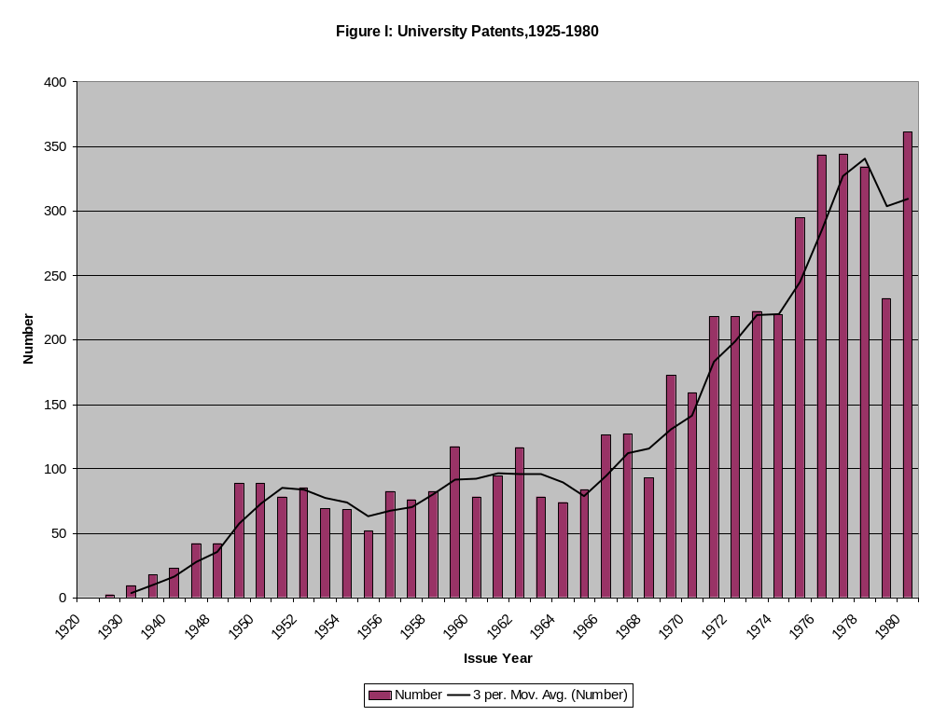
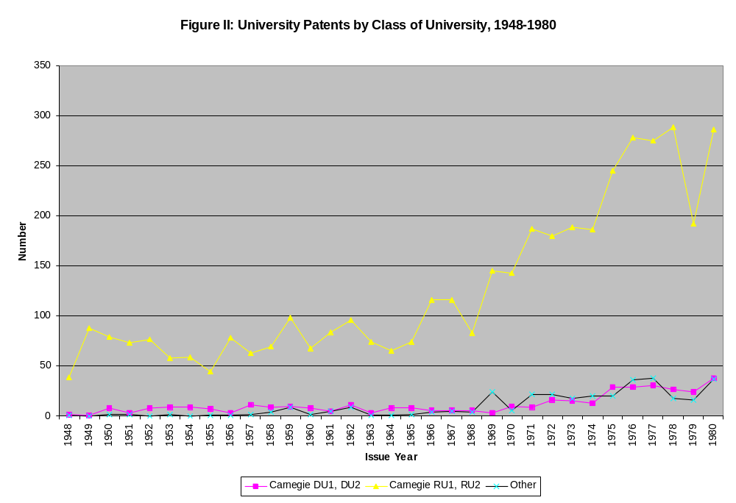
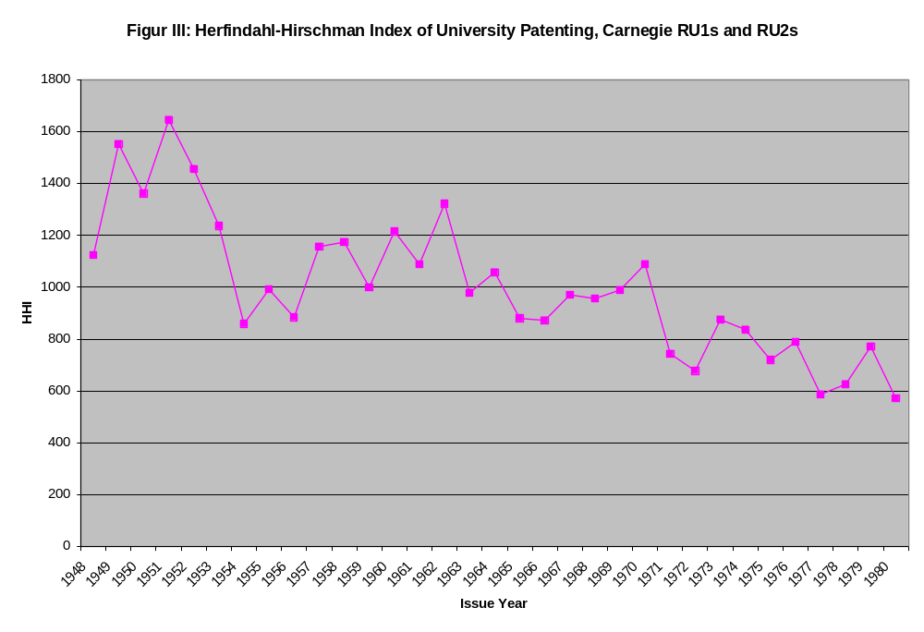
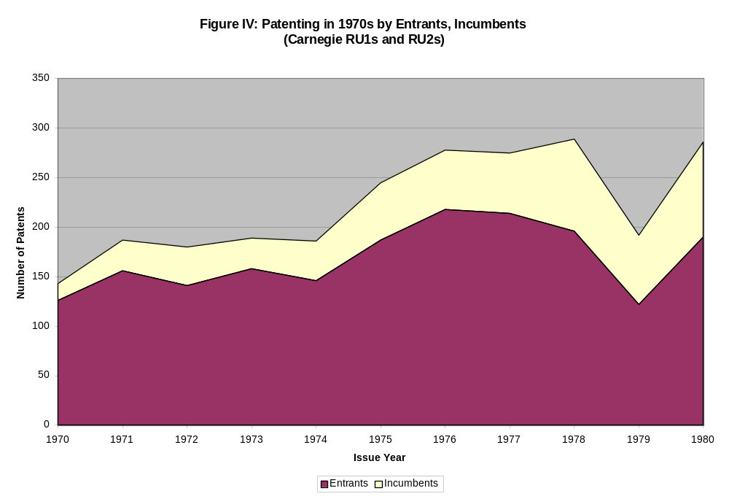
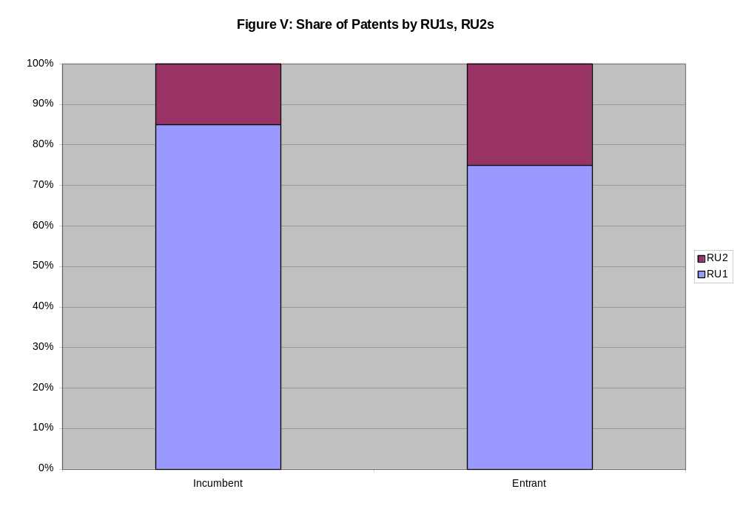
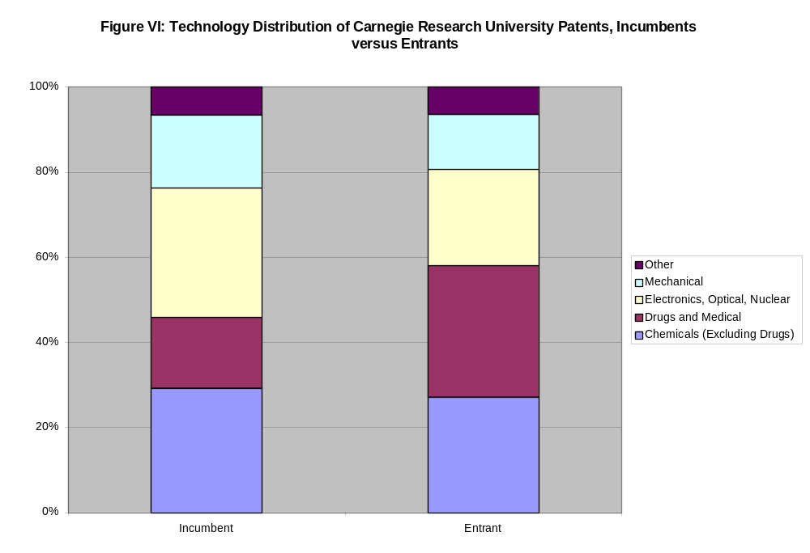
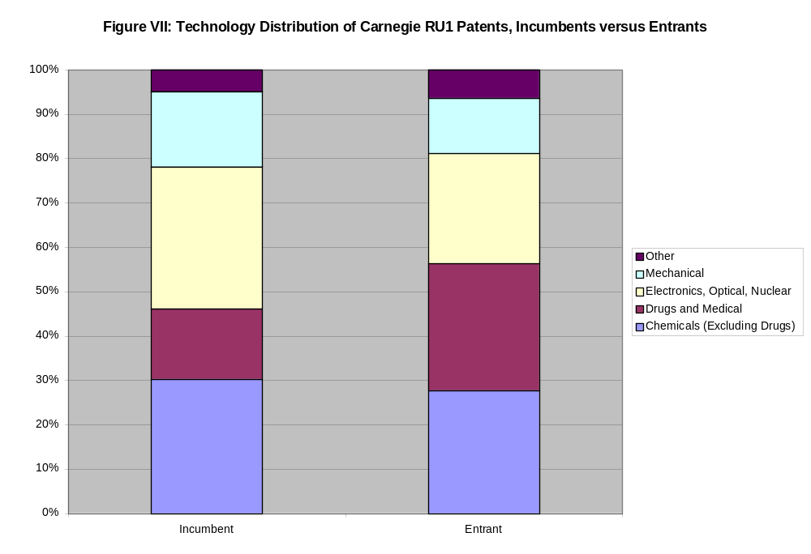
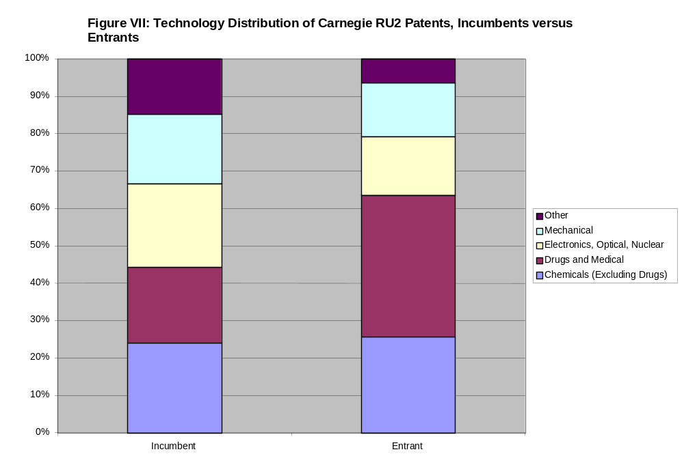
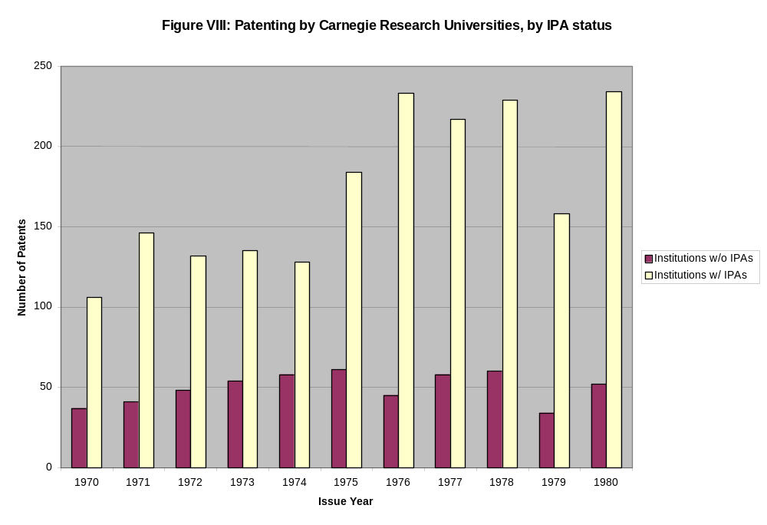
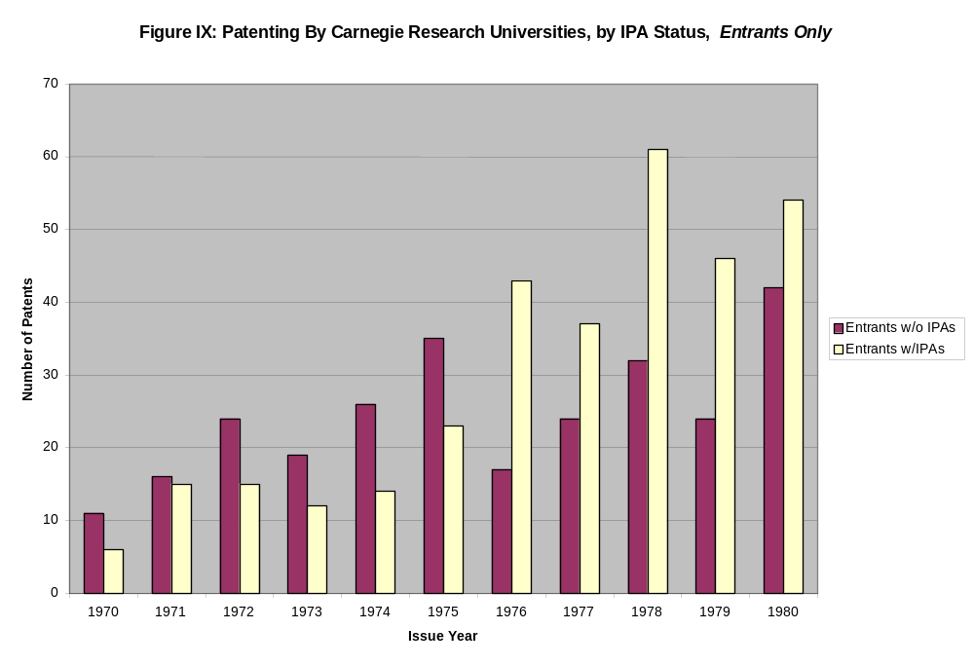
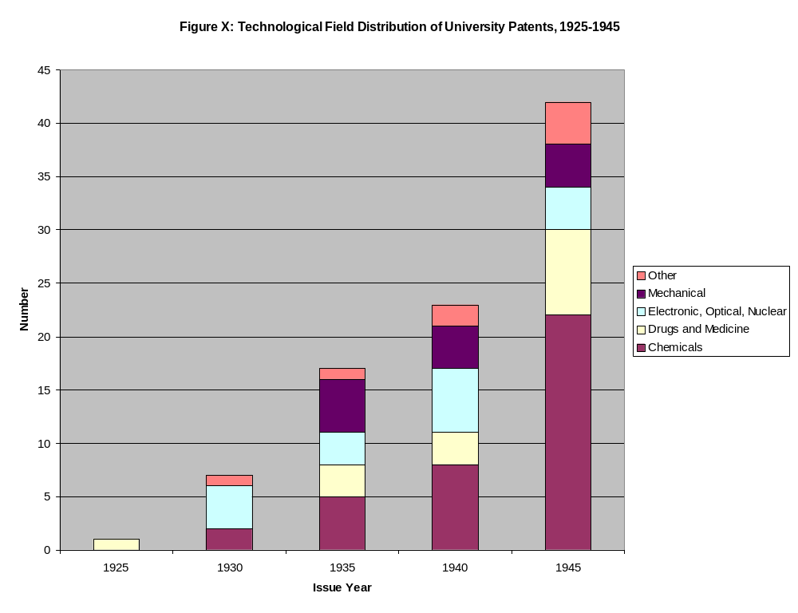
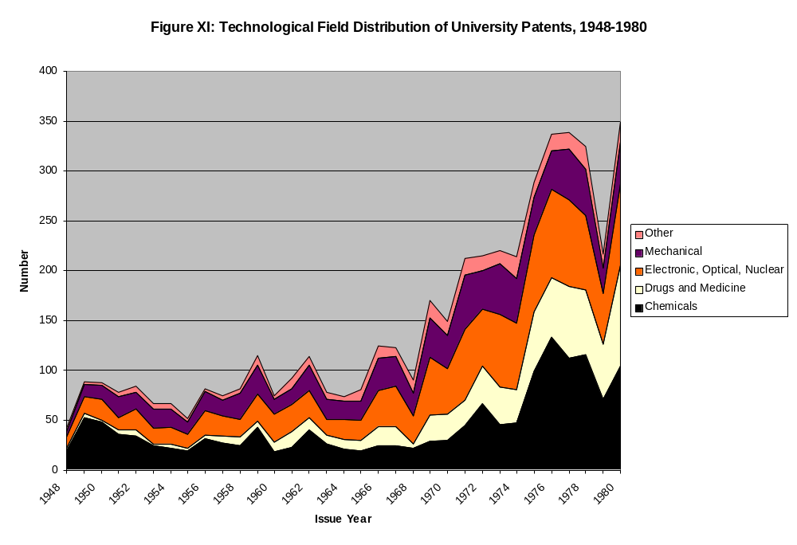
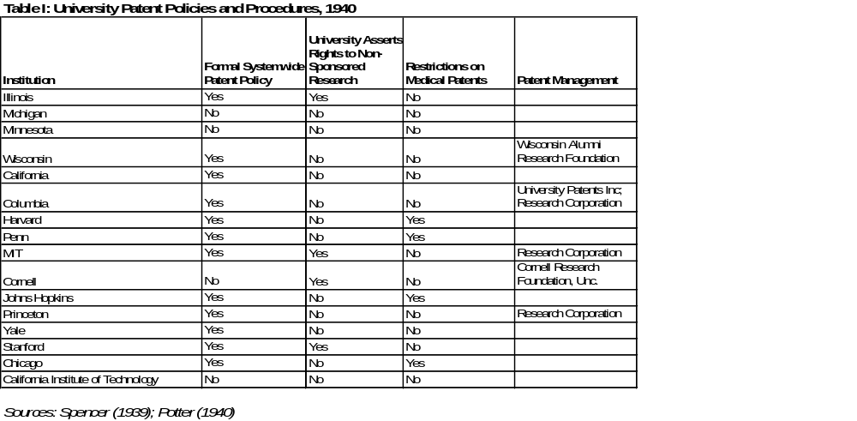
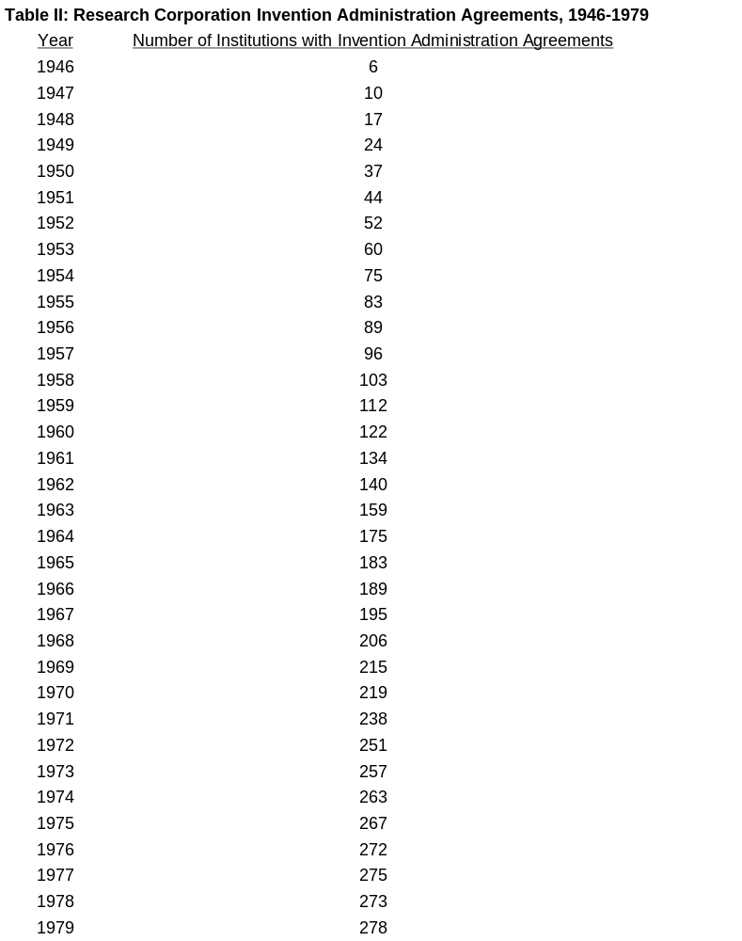
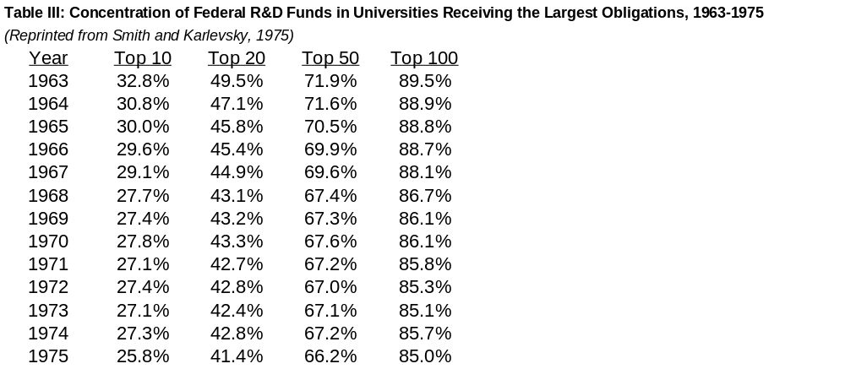
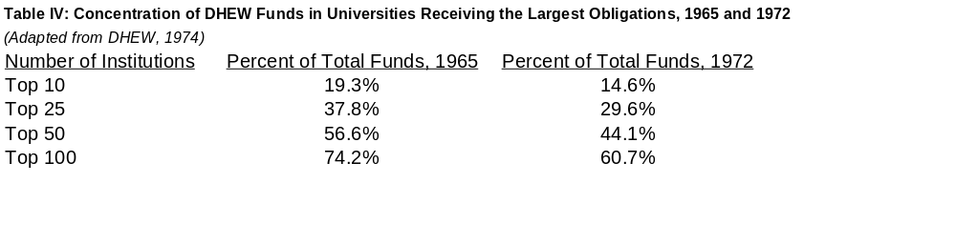
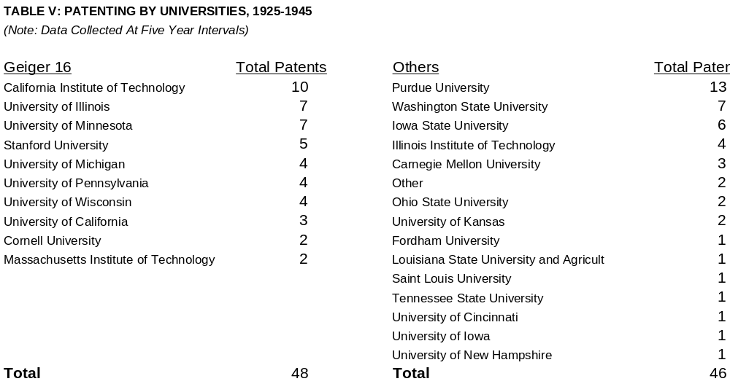

Table VI: Carnegie Research Universities with Research Corporation IAAs
 | Number with IAAs with Research Corporation
 | Percent with IAAs with Research Corporation
Type of University | 1950 | 1955 | 1960 | 1965 | 1970 | 1975 | 1980
RU1 and RU2 (N=89) | 20 | 39 | 51 | 59 | 62 | 68 | 68
 | 22% | 44% | 57% | 66% | 70% | 76% | 76%
- Public (N=54) | 11 | 22 | 33 | 40 | 40 | 43 | 43
 | 20% | 41% | 61% | 74% | 74% | 80% | 80%
- Private (N=35) | 9 | 17 | 18 | 19 | 22 | 25 | 25
 | 26% | 49% | 51% | 54% | 63% | 71% | 71%
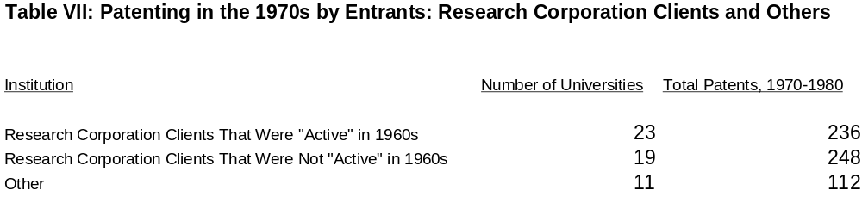

McCusick (1948) suggests that "At the beginning of the Depression decade … [t]wo different factors had turned university attention to the patent problem: first, a steady growth of research sponsored cooperatively by industry demanded a generally applicable policy toward resulting patents, and, secondly, spectacular inventions on university campuses demanded immediate concern with patent policy" (212). Moreover, he notes that the frequency of such "spectacular inventions" increased dramatically over the 1930s. Sevringhaus (1932), Gregg (1933), Henderson (1933), and Gray (1936) all provide additional contemporary accounts of these debates.
The Report, entitled "The Protection by Patents of Scientific Discoveries," deals with patents on "scientific discoveries" generally, not just from universities. But most of the discussion (even outside of Part III, which specifically deals with "University Patents") is concerned with patenting by universities and other non-profit institutions, as opposed to by scientists working in firms or independently.
It was well recognized that the traditional argument for patent protection, on the necessity of patents to induce inventions, was misplaced in the context of scientific discoveries. The AAAS report quoted Waite of the University of Michigan Law School, who noted "[C]ertainly nobody supposes the need to offer rewards for the discovery of scientific truths. The best minds in the world are already searching for these truths. There are no better minds to be brought into the game by hope of reward" (AAAS 1934, 34).
The Committee’s cautious language indicates an awareness that in some instances commercial development could proceed apace without patent protection. This distinction was largely ignored in the debates that led to the passage of Bayh-Dole (U.S. Senate 1979; Mowery et al. 1999).
The Committee quotes Hoskins and Wiles (1921) who note: "There is at large a type of engineer commonly called a 'patent pirate,' who thrives by monopolizing the practical applications of the abstract discoveries of others. The patent pirate is a menace to industry and a parasite on the community. Nothing would so hamper his activities as to have the real discoverer take out broad patents in every case." These scholars also suggested that "industry at large would be vastly better off if all discoveries were patented as fast as they are made providing only that a liberal policy was followed in licensing the use of these discoveries.' Hoskins and Wiles are less successful, however, in explaining why publication alone, which would place the knowledge in the public domain and reduce the novelty and nonobviousness of any patents based on such work, could not deter attempts to "pirate" scientific research.
The Committee’s report quoted Sevringhaus (1932): "The public is thereby protected against certain ruinous types of exploitation. Assurance can be gained that technical processes are used in dependable ways. Even the publicity may be kept on a satisfactorily high plane" (233-4).
The AAAS Committee Report characterized the following position, in an article in the Journal of Bacteriology, as typical: "The invention of an improvement in the mechanism of automobiles, or of a shoe-buckle, concerns matters of convenience or luxury, and can be dispensed with easily by those who are forced to do without them. The relief of the sick and the prevention of unnecessary sorrow by the maintenance of individual and public health are matters in a different category. As soon as we are in possession of the knowledge of principles or methods which can contribute to these purposes their free utilization becomes a public necessity; and any procedure which inhibits their most rapid and effective application to the needs of the community would seem to us as unjustified as the cornering of the wheat market or the patenting of the process of making bread" (15).
Palmer (1957) later noted that patents at agricultural and engineering experiment stations in particular were infrequent, and were taken out only as a mechanism to protect the public. Typically, they were licensed on a non-exclusive and royalty-free basis.
Universities had, of course, considered the possibility of patent profits before, but they had usually spurned the proposition, believing that with the bad publicity that might accompany patent exploitation the university endowment might in the end actually suffer financially. This last fear, though still effective in the thirties, was overpowered by compelling needs for new sources of income. University administrators turned to working out methods of patent management that would not be detrimental to their public relations.” (McKusick, 1948, p. 213)
According to Apple (1996) Steenbock sought to ensure that "…business matters would not concern or distract the university from its educational mandate; yet academe could reap the rewards from a well-managed patent whose royalties would pay for other scientific work" (42).
Indeed, these and other actions eventually led the Department of Justice to charge Wisconsin with antitrust violations, further sullying its reputation.
Of these 85 policies, 3 were adopted prior to 1930; 6 between 1931 and 1935; 12 between 1936 and 1940; 19 between 1941 and 1945; 25 between 1946 and 1950; and 20 between 1951 and 1955.
“Patent management is a complicated business and is expensive. It requires a high degree of legal competence, administrative astuteness, and promotional zeal--a combination of talent not always readily available in an educational institution. The patent search is a specialized technical job. The preparation and processing of patent applications is exacting work for legal counsel. The administration of patent rights demands careful attention to intricate details and constant watch for infringement. The exploitation and disposal of patents, through sale and licensing agreements, requires salesmanship of a high order. It is natural, therefore, that most educational institutions make every effort to avoid becoming directly involved in the intricate legal and commercial aspects of patent management.” (Palmer, 1947)
These numbers should be interpreted cautiously; the Research Corporation administered patents not only for universities, but also for other nonprofit institutions. The number of Invention Administration Agreements reported includes those for all institutions, although the vast majority of such agreements were with universities. Table VI which is limited to "research universities," shows growth in the number of institutions with IAAs over this period.
Columbia's policy thus continued "It is recognized, however, that there may be exceptional circumstances where the taking out of a patent will be advisable in order to protect the public. These cases must be brought to [administration] for its consideration and approval".
According to the "Report on University Patent Fund and University Patent Operations for the Year ended June 30, 1968" of the Board of Regents of the University of California, "The United States Public Health Service (PHS) of the Department of Health, Education, and Welfare is revising its Institutional Agreements under which patent rights can be retained by educational institutions. The PHS intends to make these Institutional Agreements available to many more institutions than at present. At the same time, it is making its patent provisions more restrictive. Most objectionable of the provisions included in the draft under consideration are: (1) a limitation on the amount of royalty the University can share with its inventors, and (2) a requirement that the University and its licensees provide the Government with copies of all licenses, and that the University incorporate into commercial licenses the provisions of the Institutional Agreement." (11/1/68, p. 4).
These uncertainties were compounded by the fact that, dating back to a 1920 order by the Attorney General, agencies were not legally allowed to turn over title to contractors without legislative approval. Though agencies like DOD, HEW, and NSF had gotten around this via maintenance of "march in" rights, there was still considerable uncertainty about whether these would hold up in court.
The population of university assignees includes the union of all assignees designated as "universities" in the Case Western-NBER US Patents database and all institutions designated as research or doctoral universities in the Carnegie Commission's 1973 report. To collect patents assigned to these universities, we searched the U.S. Patent and Trademark Office's Annual Reports for patents assigned to these institutions 1920-1965 (there were none in 1920, other than patents assigned to the Research Corporation), the DIALOG Corporation's Patents/CLAIMS database for patents from 1963-1980, and the Case Western-NBER database for patents from 1975-1980. Searches of multiple sources for the 1963-1965 period and the 1975-1980 produced similar results. Unless otherwise specified, "university patents" refer to this entire sample of patents.
It is noteworthy that the increase in university patenting over the 1970s occurred while overall U.S. patenting was decreasing.
Importantly, while the growth of university patenting in the 1970s was impressive (the average compounded growth rate was 4.7% annually between 1971 and 1980) it was considerably higher in the 1980s (the average compounded growth rate was 11.6% between 1981 and 1990). However, the average compounded growth rate of university patents as a share of total utility patents was similar over these periods, 7.4% in the 1970s and 7.7% in the 1980s.
These calculations exclude Research Corporation patents.
In its 1973 report, the Carnegie Commission on Higher Education classified the nation's 173 doctorate granting institutions as Research Universities and Doctoral Universities. Institutions that awarded at least 50 doctorates in 1969-1970 and were among the 50 leading recipients of federal financial support in at least two of the three years 1968-1969, 1969-1970, 1970-1971 were classified as "Research University I" (RU1). Institutions that awarded at least 50 doctorates in 1969-1970 and ranked in between 50th and 100th in federal financial support in two of the three years were classified as "Research University 2" (RU2). Our “Doctoral Universities” category includes all other institutions that granted more than 10 patents in the 1969-1970 period. To collect patents for these institutions, we classified multi-campus universities by the maximum ranking of any campus in the system, a procedure that is necessary because patents are typically assigned at the university, not the campus, level. This procedure yielded 89 unique "Research Universities" (49 RU1s and 40 RU2s) and 73 “Doctoral Universities.” Within these groups, 79 of the Research Universities (all 49 of the RU1s, 30 of the RU2s) and 40 of the Doctoral Universities had at least one patent during the 1948-1980 period.
The basic trends presented below are not affected by using threshold values other than 10.
Of the 40 institutions with IPAs, 23 had an IPA only with HEW, 1 only with NSF, and 16 with both agencies.
The technological areas we use here are based on a concordance from U.S. patent classes to technological fields developed by Adam Jaffe, and reported in Jaffe, Fogarty, and Banks (1999).

